Part 4: Get an Apple Device Enrollment token
- In the Microsoft Endpoint Manager admin center, choose Devices > iOS/iPadOS > iOS/iPadOS enrollment > Enrollment Program Tokens > Add.
- Grant permission to Microsoft to send user and device information to Apple by selecting I agree.
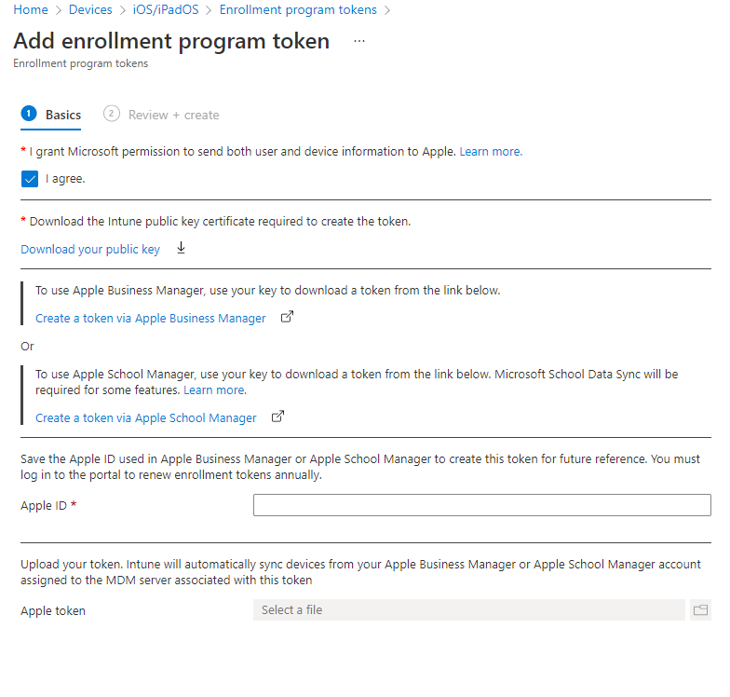
- Choose Download your public key to download and save the encryption key (.pem) file locally. The .pem file is used to request a trust-relationship certificate from the Apple portal.
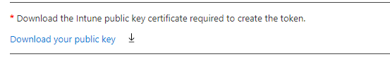
- Choose Create a token for Apple's Device Enrollment Program to open Apple's Deployment Program portal, and sign in with your company Apple ID. You can use this Apple ID to renew your token.
- In Apple Business Manager, Setings>Devce management Settings>choose Add MDM Server.
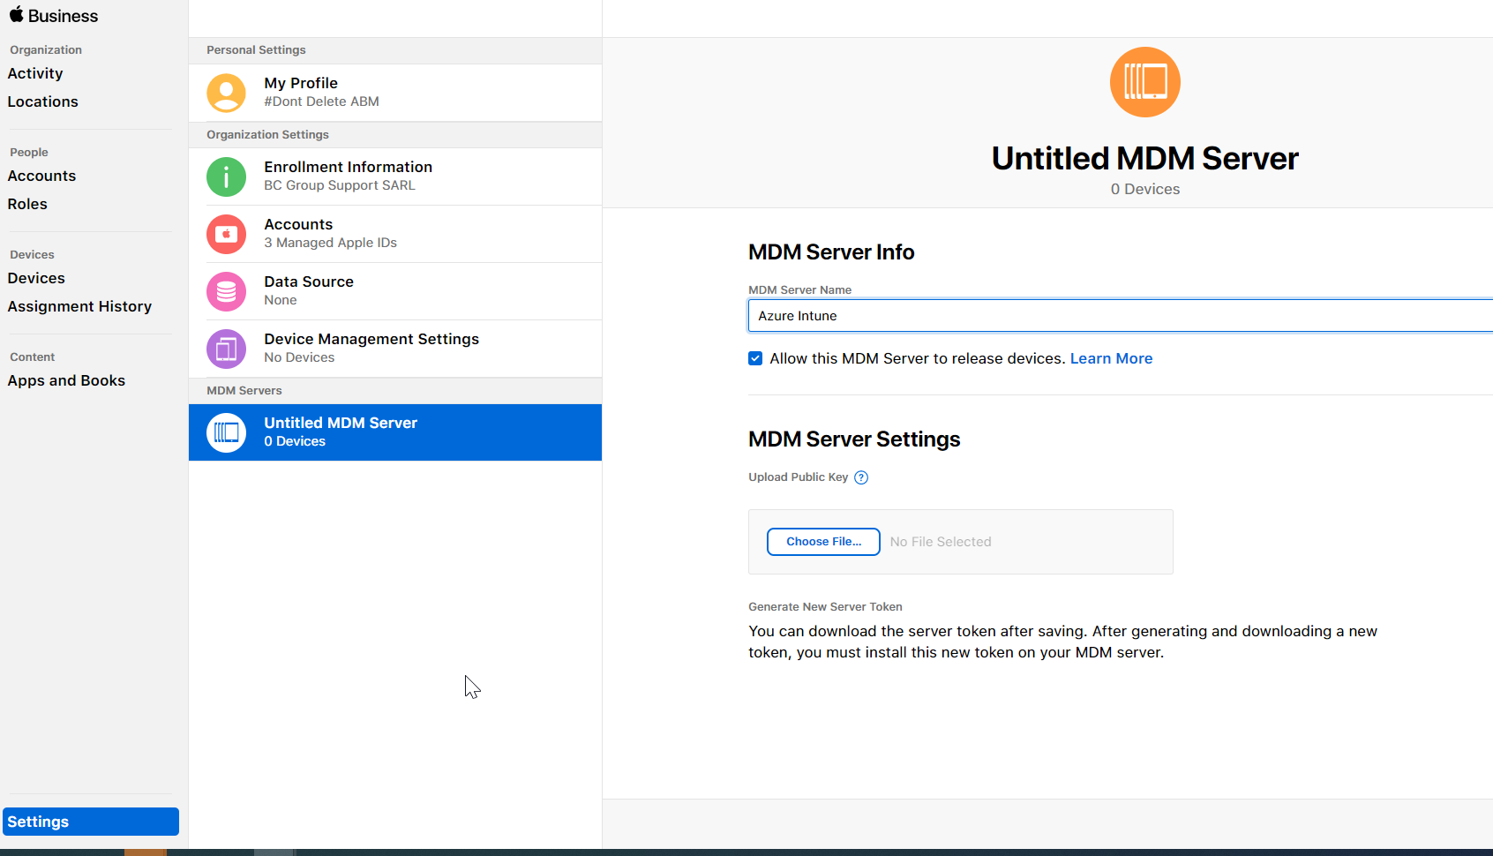
- For MDM Server Name, enter Azure Intune and Upload Your Public Key. Select Choose File… to upload the .pem file, and then choose Save
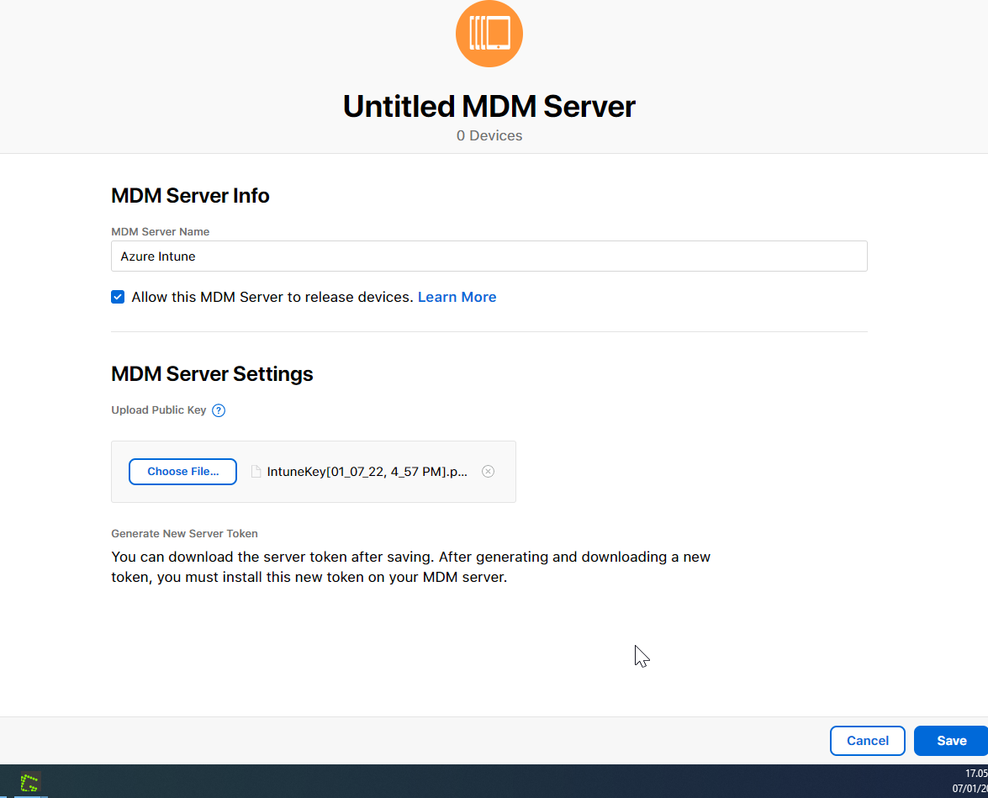
- Download Token and save locally. Settings>Azure Intune>Download Token
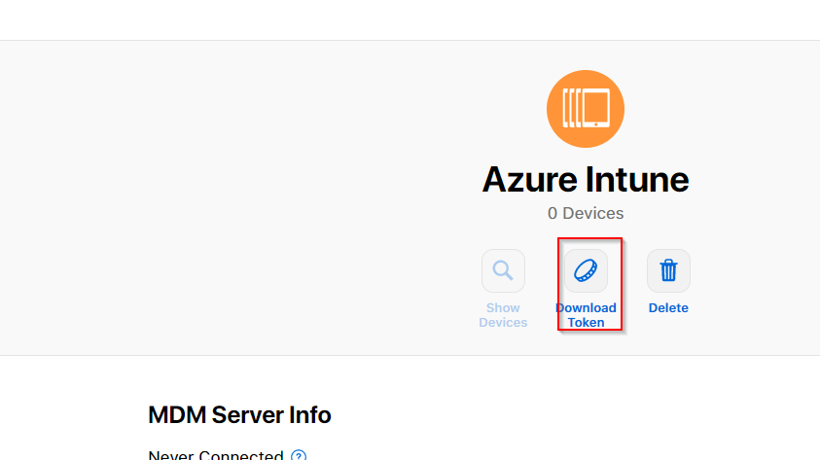
- Save the Apple ID used in Apple Business Manager or Apple School Manager to create this token for future reference. You must log in to the portal to renew enrollment tokens annually.
Over here use the apple id as used before.
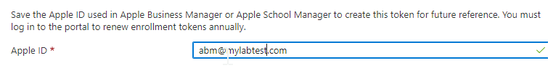
- Upload the token from Step 7 and Select, Next
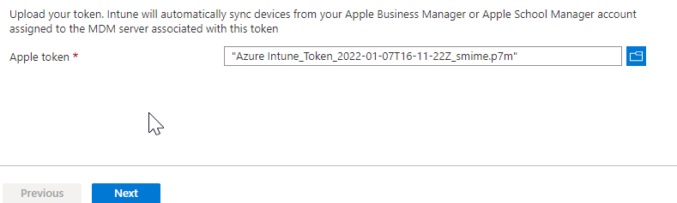

- Create

